CAT-5 Cross-over Cable Pin Assignments
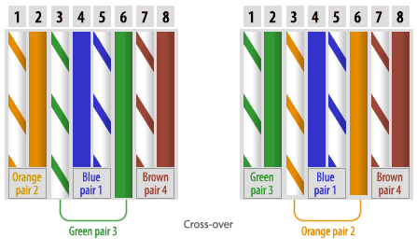

CAT-5 Straight-through Cable Pin Assignments
